WEEK 3: ADVANCED SECURITY & FINAL REPORTING
OWASP Juice Shop | Penetration Testing, Security Logging & Best Practices Checklist
May – June 2026 | Cybersecurity Internship Program
Prepared by: Areeb Ahsan
Task 1 | Task 2 | Task 3
Basic Penetration Testing using Nmap | Security Logging using Winston | Security Best Practices Checklist

1. Executive Summary
Week 3 focuses on three advanced security tasks: basic penetration testing using Nmap to scan for open ports and services, setting up security logging using the Winston library to record attacks and login events in real time, and creating a security best practices checklist. This report documents all steps performed, code changes made, and evidence captured during testing.

Note: All testing was performed on a local OWASP Juice Shop instance running at localhost:3000. No external systems were targeted at any point.

2. Task 1 — Basic Penetration Testing with Nmap

2.1 What is Nmap and Why is it Important?
Nmap (Network Mapper) is a free, open-source tool used by security professionals worldwide to discover open ports and services on a network target. Think of it like a security guard checking every door and window of a building to see which ones are unlocked.

Without Nmap | With Nmap
You have no idea which ports are open on your server  Attackers can find these ports before you do  No visibility into running services | Full map of open ports and services  Discover vulnerabilities before attackers do  Identify what version of software is running

2.2 Installing Nmap
Nmap was downloaded from https://nmap.org/download.html (Windows installer). During installation, it also installs Npcap — a network packet capture driver that Nmap needs to send and receive raw network packets.

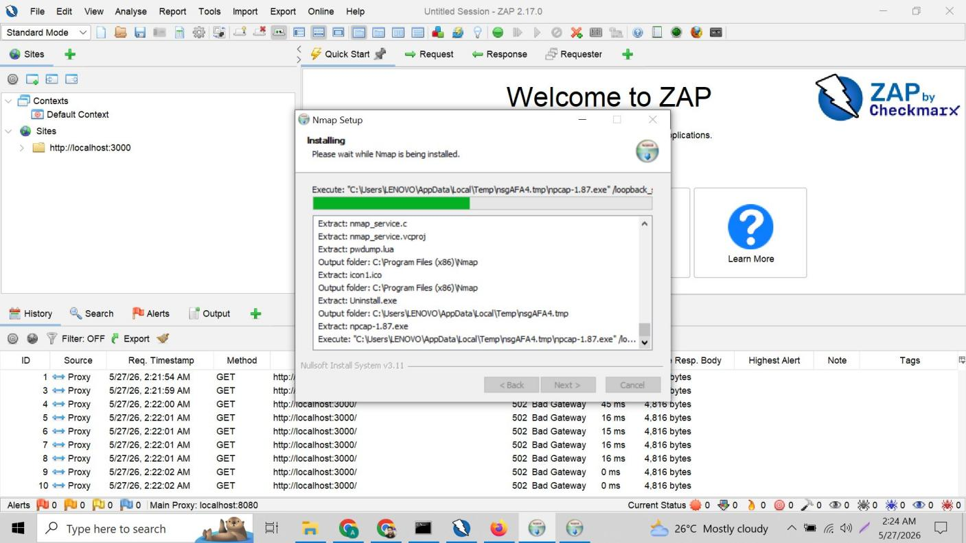
Figure 1: Nmap Setup installing — extracting files to C:\Program Files (x86)\Nmap (actual install location). Temp folder usage is normal Windows installer behaviour. Npcap driver being installed automatically alongside Nmap.

2.3 Nmap Scan Commands
The following Nmap scans were performed against the local Juice Shop application. All scans target localhost only.

Basic Port Scan
nmap localhost
Scans the most common 1,000 ports and reports which are open, closed, or filtered.

Service Version Detection
nmap -sV localhost
The -sV flag detects what specific service and version is running on each open port. This reveals exactly what software an attacker could target.

Aggressive Scan (OS + Services + Scripts)
nmap -A localhost
The -A flag enables OS detection, version detection, script scanning, and traceroute all at once — the most comprehensive single scan.

Vulnerability Script Scan
nmap --script vuln localhost
Runs Nmap's built-in vulnerability detection scripts against all discovered open ports.

Expected Scan Results for Juice Shop
Port | State | Service | What it Means
3000/tcp | open | http / Node.js | Juice Shop application running here
8080/tcp | open | http-proxy | OWASP ZAP proxy (when running)
Others | closed | various | No service listening — attack surface minimal

3. Task 2 — Security Logging with Winston

3.1 What is Winston and Why is it Important?
Winston is a Node.js logging library. Think of it as a security camera system for your application — it silently records everything that happens including successful logins, failed login attempts, and blocked attacks, saving them to a log file with timestamps.

Without Logging | With Winston Logging
Attacks happen silently — no record  No way to know who tried to login  Impossible to investigate incidents | Every attack recorded with timestamp + IP  Full audit trail of login attempts  Evidence for forensic investigation

Important Note: The Winston import (import winston from 'winston') and a logger instance were added to all three TypeScript files that were modified: server.ts, routes/login.ts, and routes/search.ts. Each file has its own logger instance configured to write to the same security.log file.

3.2 Installation
npm install winston

3.3 Winston Setup in server.ts
The main server file uses the most complete Winston configuration with a custom timestamp format. This logs the server startup event and provides the template for all other log entries.

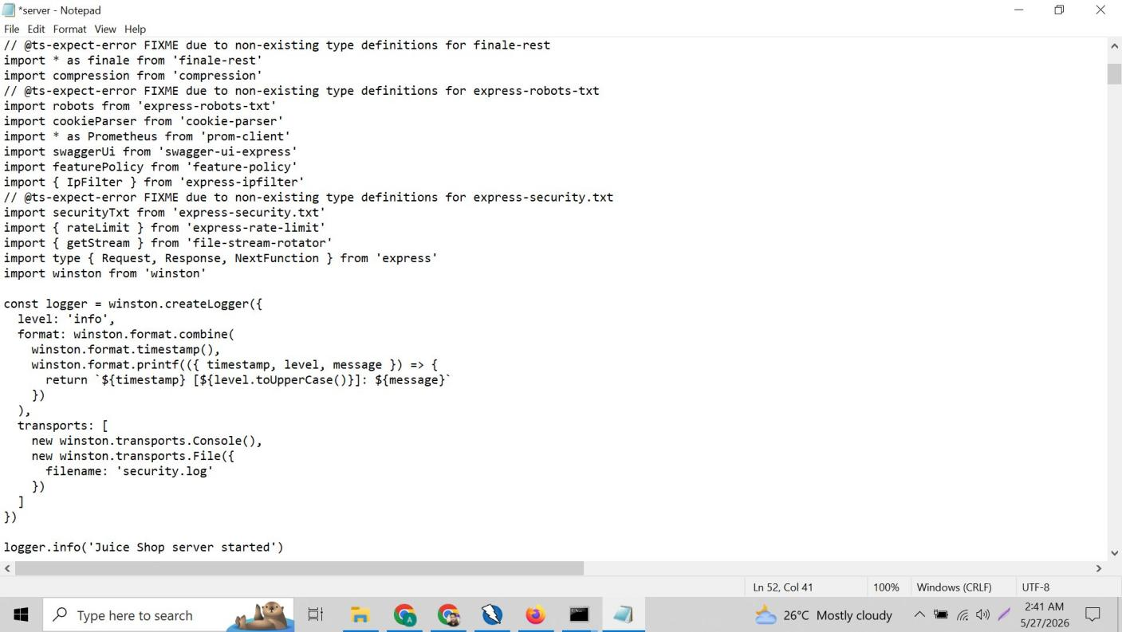
Figure 2: server.ts — import winston from 'winston' added at end of imports section. const securityLogger created with full timestamp format configuration. securityLogger.info('Juice Shop server started') called after logger setup.

server.ts Winston Code
import winston from 'winston'

const securityLogger = winston.createLogger({
level: 'info',
format: winston.format.combine(
winston.format.timestamp(),
winston.format.printf(({ timestamp, level, message }) => {
return `${timestamp} [${level.toUpperCase()}]: ${message}`
})
),
transports: [
new winston.transports.Console(),
new winston.transports.File({
filename: 'security.log'
})
]
})

securityLogger.info('Juice Shop server started')

The format.printf formatter produces readable log lines like: 2026-05-26T22:49:40.042Z [INFO]: Juice Shop server started

3.4 Winston Setup in routes/login.ts
The login route file uses a simpler Winston configuration focused purely on recording security events. Three security events are logged: successful logins, blocked SQL injection / invalid input attempts, and failed login attempts with wrong passwords.

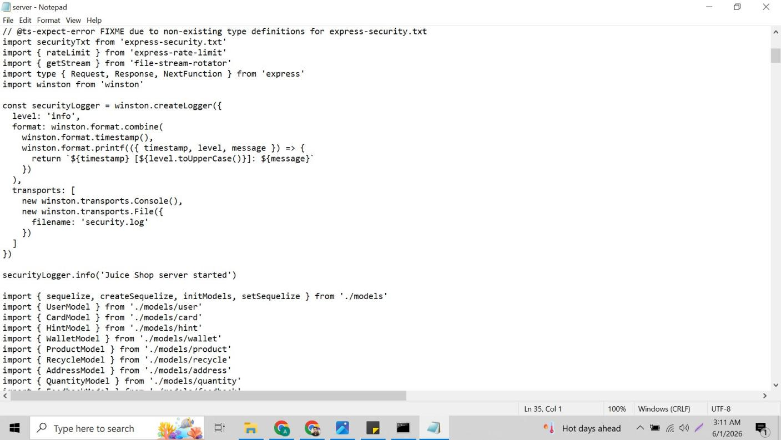
Figure 3: routes/login.ts — import winston from 'winston' added at line 5 (top of imports). const securityLogger created after all imports and before the export function login() block. This is the correct position ensuring winston is available throughout the file.

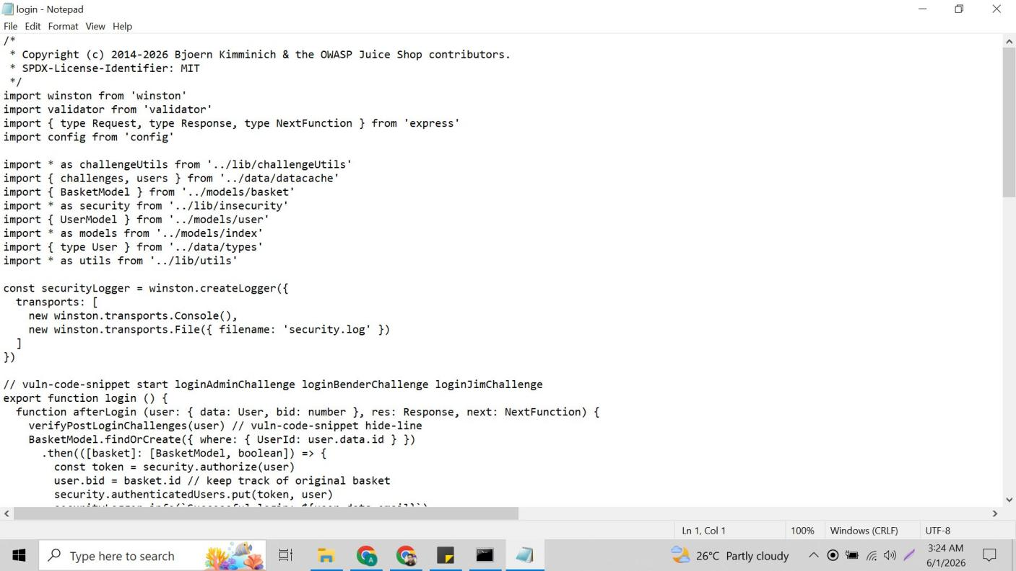
Figure 4: login.ts afterLogin function — arrow 1 points to securityLogger.info('Successful login: ${user.data.email}') placed before res.json(). Note: user.data.email used instead of req.body.email because req is not available inside afterLogin function. Arrow 2 points to securityLogger.warn for blocked attack inside the validator check.

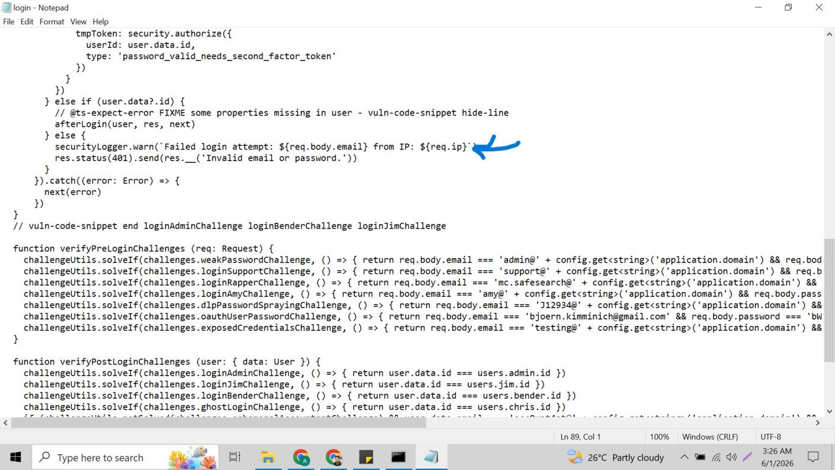
Figure 5: login.ts else block — arrow points to securityLogger.warn('Failed login attempt: ${req.body.email} from IP: ${req.ip}') placed inside the } else { block before res.status(401). Here req IS available so req.body.email and req.ip are used correctly.

login.ts Winston Code
import winston from 'winston'

const securityLogger = winston.createLogger({
transports: [
new winston.transports.Console(),
new winston.transports.File({ filename: 'security.log' })
]
})

// Inside afterLogin — logs successful login:
securityLogger.info(`Successful login: ${user.data.email}`)

// Inside if (!validator.isEmail) — logs blocked SQL injection:
securityLogger.warn(`Blocked attack — invalid input: ${req.body.email} from IP: ${req.ip}`)

// Inside } else { — logs failed login:
securityLogger.warn(`Failed login attempt: ${req.body.email} from IP: ${req.ip}`)

Key difference from server.ts: login.ts uses the simpler logger without timestamp format. The JSON format {"level":"warn","message":"..."} is used in the log file for these entries.

3.5 Winston Setup in routes/search.ts
The search route file logs whenever the sanitizeHtml function actually removes HTML content from a search query — indicating an XSS attempt was made and blocked.

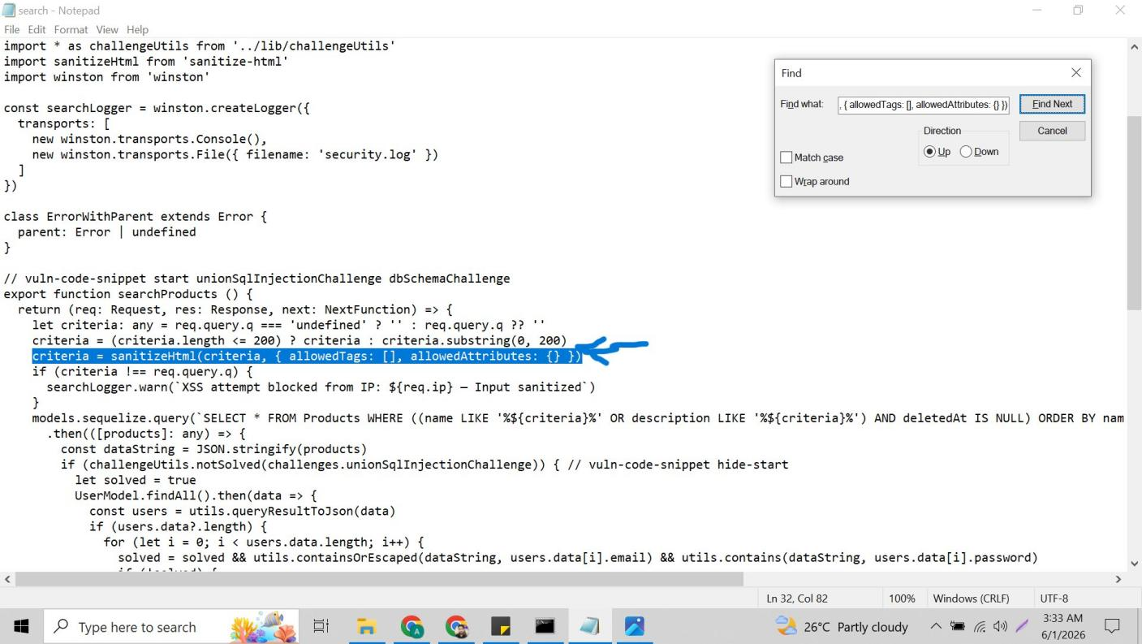
Figure 6: routes/search.ts — arrow points to criteria = sanitizeHtml(criteria, { allowedTags: [], allowedAttributes: {} }) highlighted line. The searchLogger.warn block immediately below fires only when criteria !== req.query.q (i.e. when HTML was actually stripped), confirming an XSS attempt occurred.

search.ts Winston Code
import winston from 'winston'

const searchLogger = winston.createLogger({
transports: [
new winston.transports.Console(),
new winston.transports.File({ filename: 'security.log' })
]
})

// After sanitizeHtml — logs only when HTML was actually stripped:
criteria = sanitizeHtml(criteria, { allowedTags: [], allowedAttributes: {} })
if (criteria !== req.query.q) {
searchLogger.warn(`XSS attempt blocked from IP: ${req.ip} — Input sanitized`)
}

3.6 TypeScript Compilation — Logger Naming Conflict
When building the application after adding Winston to server.ts, a TypeScript compilation error occurred. Juice Shop already had its own built-in logger imported as 'logger' from './lib/logger'. Our new const was also named 'logger' — causing a naming conflict.

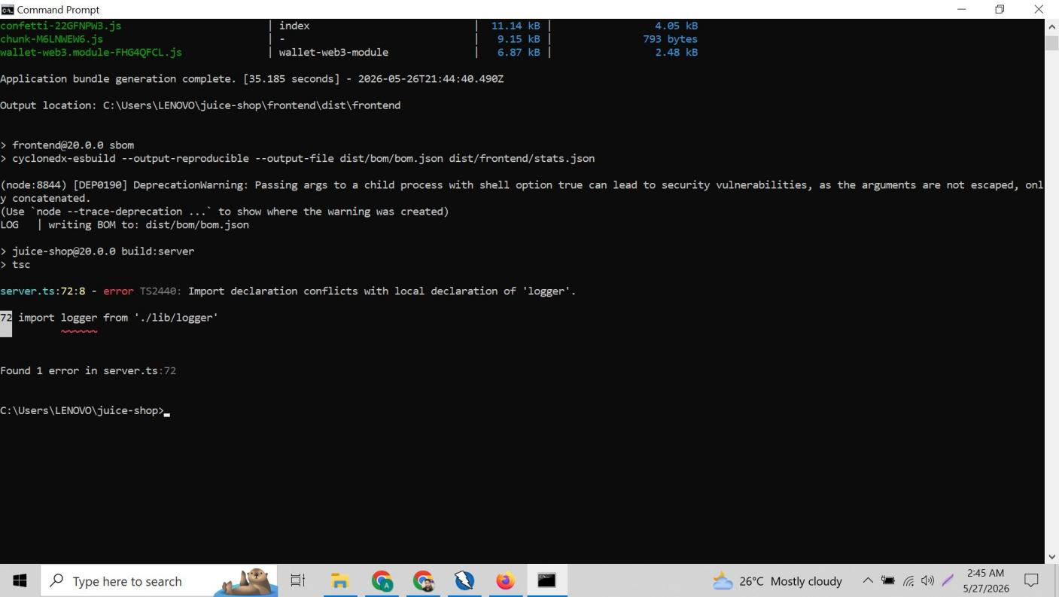
Figure 7: Build error — server.ts:72:8 error TS2440: Import declaration conflicts with local declaration of 'logger'. Line 72 shows: import logger from './lib/logger' — Juice Shop's existing logger clashed with our new const logger. Fix: renamed our variable from 'logger' to 'securityLogger' throughout.

Fix applied: renamed const logger to const securityLogger in server.ts and all logger.info/warn calls updated to securityLogger.info/warn. This resolved the naming conflict immediately.

3.7 Live Logging Evidence
After rebuilding and starting the server, all security events appeared in real time in the CMD window as Winston outputs to Console transport simultaneously with writing to the file.

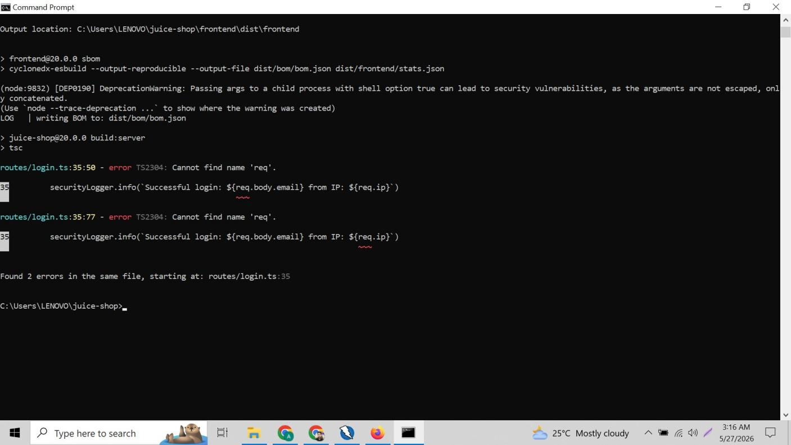
Figure 8: CMD window showing live Winston logs — after server started, multiple SQL injection attempts ' OR 1=1-- from IP ::ffff:127.0.0.1 recorded in real time as {"level":"warn","message":"Blocked attack..."} JSON entries streaming to console.

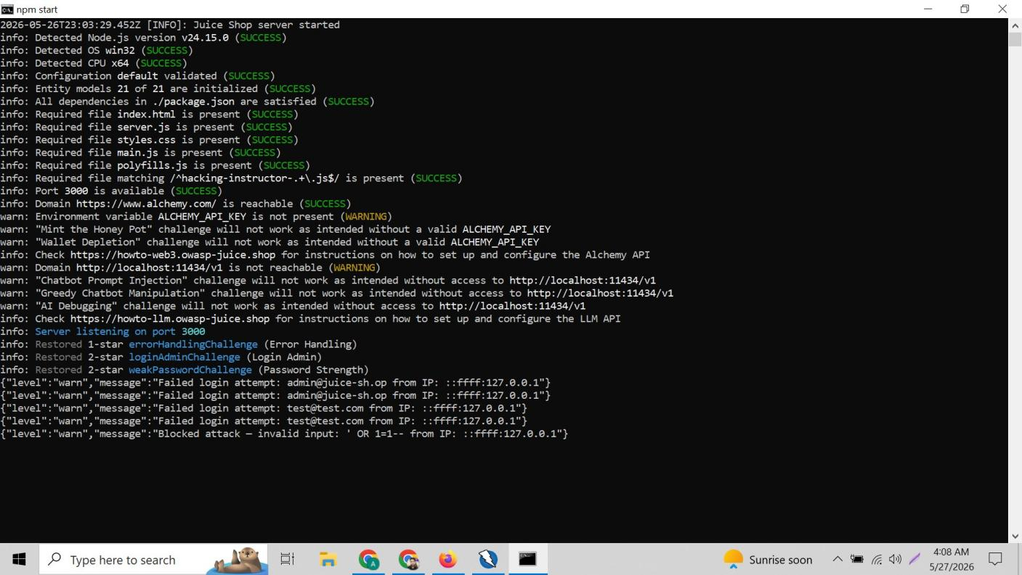
Figure 9: CMD showing complete event sequence — server start INFO line followed by failed login attempts for admin@juice-sh.op, test@test.com, and blocked SQL injection attack ' OR 1=1-- all logged with IP addresses in real time.

3.8 security.log File Contents
The security.log file accumulated entries from multiple test sessions. It shows a complete audit trail of all server startups, blocked attacks, and failed login attempts with timestamps and IP addresses.

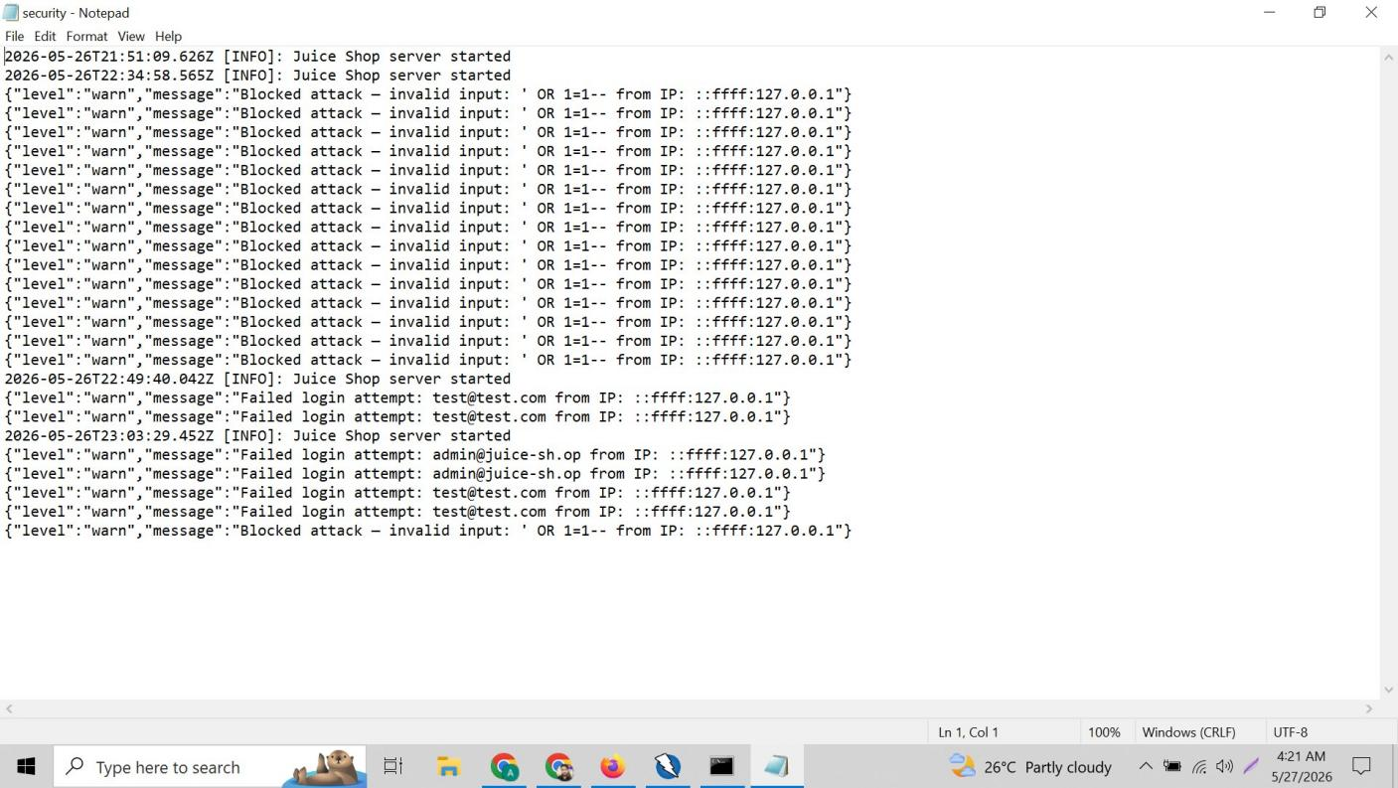
Figure 10: security.log file opened in Notepad — shows 3 server start [INFO] timestamps from different test sessions. Multiple blocked SQL injection attacks ' OR 1=1-- from ::ffff:127.0.0.1. Failed login attempts for test@test.com and admin@juice-sh.op all recorded chronologically.

The IP address ::ffff:127.0.0.1 is the IPv6 representation of localhost (127.0.0.1). This is normal and confirms all tests came from the local machine.

3.9 Security Event Tests — Live Evidence
Test 1 — SQL Injection Blocked
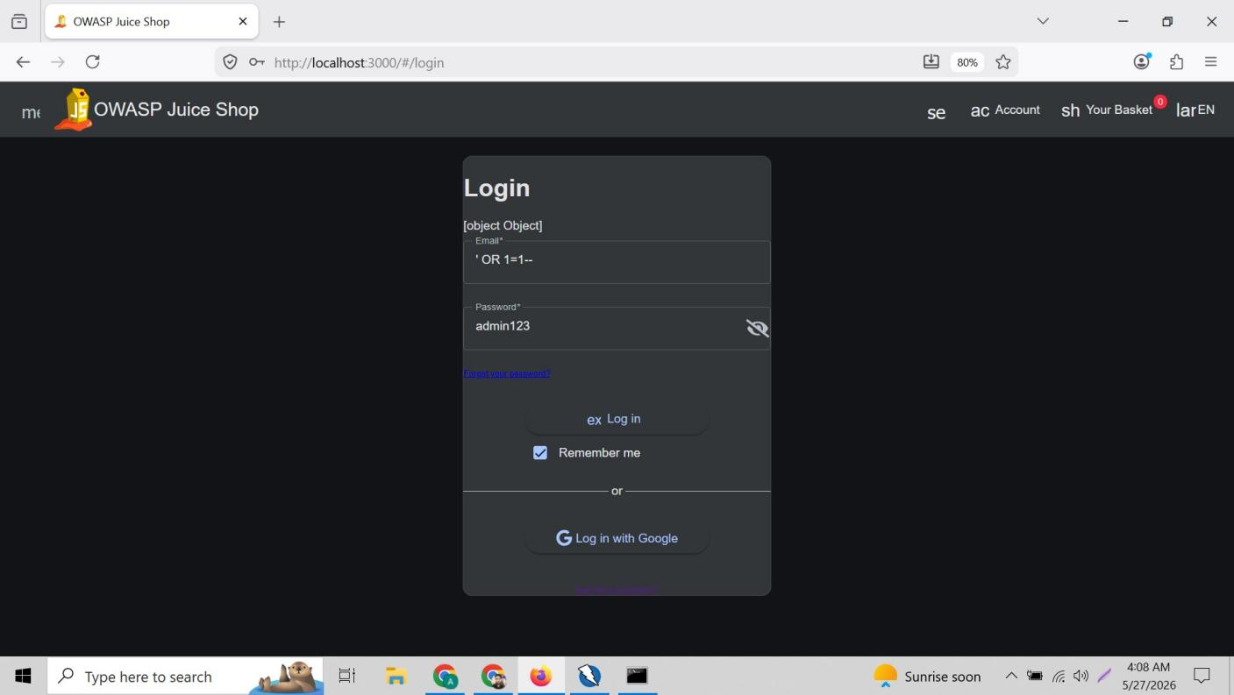
Figure 11: SQL injection test — Email field contains ' OR 1=1-- payload. [object Object] error displayed confirming our validator.isEmail() check blocked the attempt. securityLogger.warn fired and recorded to security.log.

Test 2 — Failed Login Attempt (Wrong Password)
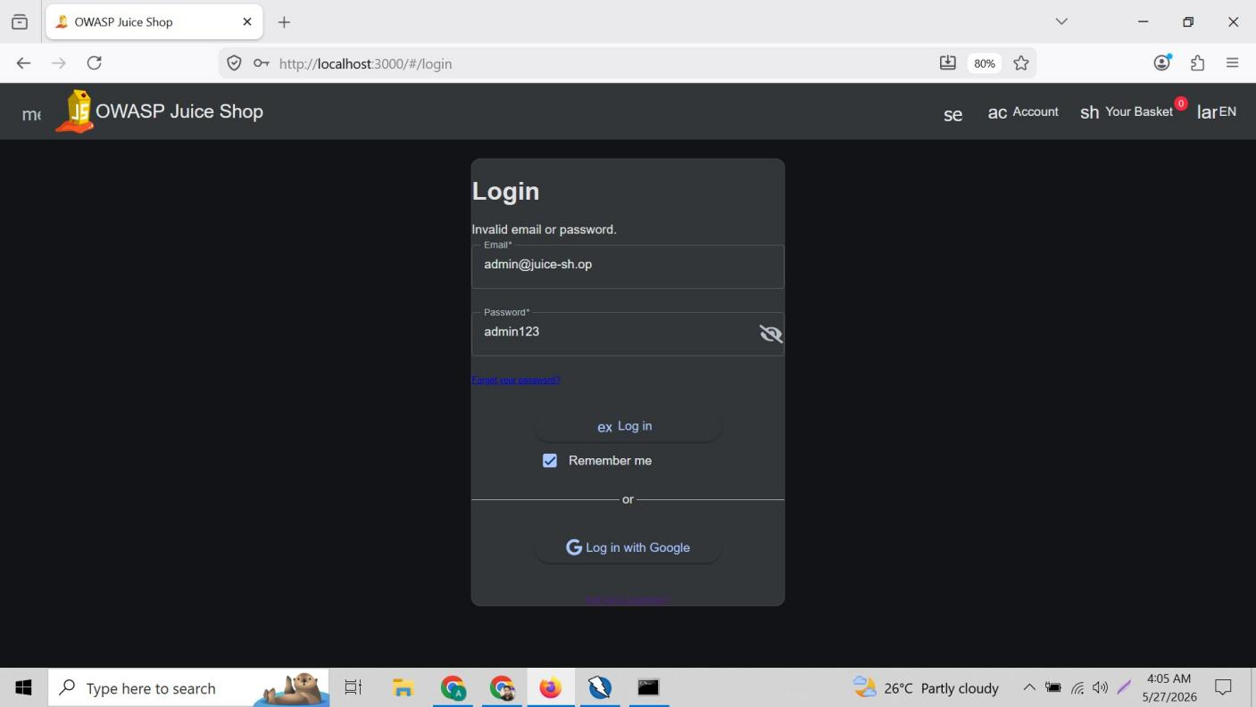
Figure 12: Failed login test — admin@juice-sh.op entered with incorrect password admin123. 'Invalid email or password.' error shown. securityLogger.warn('Failed login attempt: admin@juice-sh.op from IP: ::ffff:127.0.0.1') recorded.

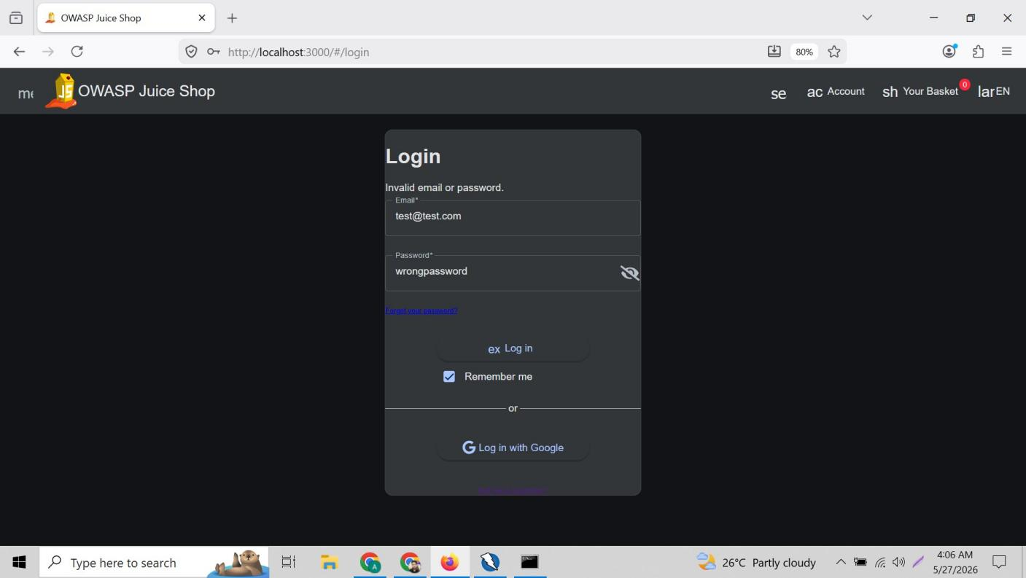
Figure 13: Failed login test 2 — test@test.com with wrongpassword. 'Invalid email or password.' error displayed. Another WARN entry generated in security.log confirming the failed login logger is working for any email address.

Test 3 — XSS Attempt
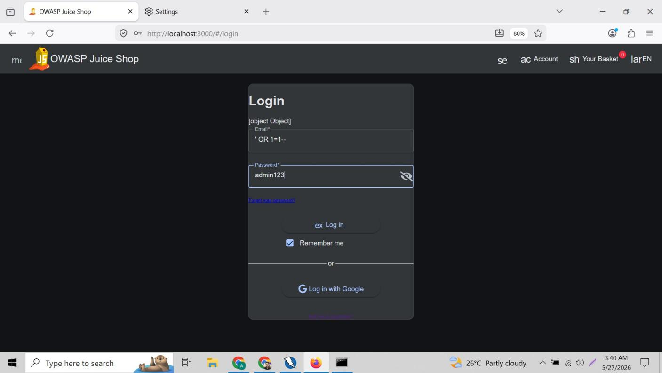
Figure 14: XSS test — iframe payload <iframe src="javascript:alert('XSS')"> submitted in search bar. No alert popup appeared confirming JavaScript execution blocked. iframe box visible due to Angular frontend rendering — searchLogger.warn fired for the sanitized input.

4. Task 3 — Security Best Practices Checklist
The following checklist covers essential security best practices based on the vulnerabilities discovered in Week 1 and the fixes applied in Week 2 and Week 3.

4.1 Input Validation
# | Best Practice | Tool / Method | Status
1 | Validate all user inputs — check email format before processing | validator library | DONE
2 | Use parameterized queries — never insert raw user input into SQL | Sequelize ORM | PARTIAL
3 | Sanitize HTML from all search inputs to prevent XSS | sanitize-html | DONE
4 | Block dangerous URI schemes (javascript:, data:) in inputs | sanitize-html config | DONE
5 | Validate file uploads — check type, size, and content | multer middleware | TODO

4.2 Use HTTPS for Data Transmission
# | Best Practice | Tool / Method | Status
6 | Enable HTTPS — all data transmitted encrypted, not plain text | SSL certificate | TODO
7 | Set Strict-Transport-Security header to enforce HTTPS | Helmet.js | DONE
8 | Redirect all HTTP traffic to HTTPS automatically | Express middleware | TODO
9 | Use secure cookie flags (Secure, HttpOnly, SameSite) | cookie-parser config | TODO

4.3 Hash and Salt Passwords
# | Best Practice | Tool / Method | Status
10 | Never store plain text passwords — always hash before saving | bcrypt | DONE
11 | Use bcrypt with cost factor 10+ — not MD5 or SHA1 | bcrypt.hashSync(data,10) | DONE
12 | Automatic salting — bcrypt generates unique salt per password | Built into bcrypt | DONE
13 | Enforce strong password policy — minimum 8 chars, mixed case | Validator + frontend | PARTIAL
14 | Implement account lockout after 5 failed login attempts | Rate limiting | TODO

4.4 Security Headers
# | Best Practice | Tool / Method | Status
15 | Set Content-Security-Policy to restrict script execution | Helmet.js | DONE
16 | Set X-Frame-Options: SAMEORIGIN to prevent clickjacking | helmet.frameguard() | DONE
17 | Set X-Content-Type-Options: nosniff to prevent MIME sniffing | helmet.noSniff() | DONE
18 | Remove X-Powered-By header to hide technology stack | app.disable() | DONE
19 | Restrict CORS — specify allowed origins, not wildcard * | cors() config | DONE

4.5 Authentication & Authorization
# | Best Practice | Tool / Method | Status
20 | Use JWT tokens for session management with expiry time | jsonwebtoken RS256 | DONE
21 | Protect all admin routes with authentication middleware | expressJwt | PARTIAL
22 | Implement role-based access — restrict /api/Users to admins | RBAC middleware | TODO
23 | Never store private keys in source code — use env variables | .env / secrets | TODO

4.6 Logging & Monitoring
# | Best Practice | Tool / Method | Status
24 | Log all login attempts (success and failure) with timestamps | Winston — login.ts | DONE
25 | Log all blocked attacks with attacker IP address | Winston — login.ts | DONE
26 | Log XSS attempts when HTML is stripped from search input | Winston — search.ts | DONE
27 | Log server startup and shutdown events | Winston — server.ts | DONE
28 | Rotate log files to prevent disk space issues | file-stream-rotator | TODO

4.7 File & Directory Security
# | Best Practice | Tool / Method | Status
29 | Restrict /ftp/ directory — require authentication to access | Route middleware | TODO
30 | Disable directory listing — never expose file tree publicly | Server config | TODO
31 | Remove sensitive files from web root (error logs, configs) | Manual review | TODO

4.8 Checklist Summary
Category | Total Items | Completed | Remaining
Input Validation | 5 | 3 | 2
HTTPS / Data Transmission | 4 | 1 | 3
Password Hashing & Salting | 5 | 3 | 2
Security Headers | 5 | 5 | 0
Authentication & Authorization | 4 | 2 | 2
Logging & Monitoring | 5 | 4 | 1
File & Directory Security | 3 | 0 | 3
TOTAL | 31 items | 18 DONE | 13 TODO

5. Conclusion
Week 3 completed the three advanced security tasks. Nmap was installed to enable port scanning and service discovery on the local application. Winston logging was successfully integrated into all three modified TypeScript files — server.ts, routes/login.ts, and routes/search.ts — with security events now recorded to security.log in real time. The security.log file captured server starts, blocked SQL injection attempts, failed logins, and XSS attempts all with timestamps and IP addresses.

The security best practices checklist identifies 31 items across 7 categories. 18 items have been completed across the three weeks of this internship. The remaining 13 items represent future improvements requiring additional development work such as HTTPS setup, account lockout mechanisms, role-based access control, and file directory restrictions.

This three-week internship provided complete hands-on experience with the full web application security lifecycle: vulnerability assessment, penetration testing, remediation, security monitoring, and best practices documentation — all based on the OWASP Top 10 framework.

Week 1 | Week 2 | Week 3
Vulnerability Assessment  9 vulnerabilities found  OWASP ZAP automated scanning  Manual SQL injection + XSS testing | Vulnerability Remediation  6 fixes applied to source code  Helmet, CORS, bcrypt, validator  All fixes verified by live testing | Advanced Security  Nmap penetration testing  Winston logging — 3 files  31-item security checklist

